 | Year 12 Methods  Term 2 Week 8 Quiz | $$\frac{}{16}$$

Name: __________________
1. | A cylindrical drum, or radius r m and height h m, has circular ends constructed from material costing $75 per square metre and sides constructed of material costing $40 per square metre.  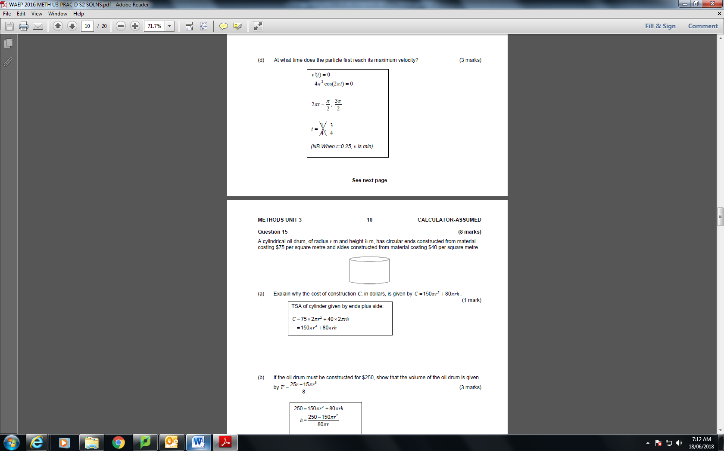  - Explain why the cost C, in dollars, is given by $C=150πr^{2}+80πrh$.  - If the oil drum must be constructed for $250, show that the volume of the oil drum is given by $v=\frac{25r-15r^{3}}{8}$.  - Use calculus methods to determine the dimensions that maximise the colume of the oil drum, and state this maximum value. | 1  3  4
2. | A manufacturer of chocolate produces 3 times as many soft centred choclates as hard centred ones. The chocolates are randomly packed in boxes of 20.  - Find the probability that in a box there are:  - an equal number of soft centred and hard centred chocolates.  - fewer than 5 hard centred chocolates.  - A random sample of 5 boxes is taken from the production line. Find the probability that exactly 3 of them contain fewer than 5 hard centred chocolates.  - Determine the mean and standard deviation of the number of hard centred choclates in a box. | 3  1  2  2

